**Project Documentation**

**Advanced Cross-Platform Application Programming with .Net**

**Prepared by Tran Dinh Vinh – HE163946**

**Hanoi, Fall – 2023**

# **Table of Contents**

## **Project introduction**

### Perspective

### Use cases

## **Database Design**

## **System Architecture**

## **Implementation**

### Installation Instruction

### Screenshots and explanations

1. **Project Introduction**

**1.1 Product perspective**

A dairy company needs to buy daily feed for cows including grass, corn, bran... and seasonally hire doctors to take care of the cows. Every day food carts entering the company are weighed through a weighing system or imported by hand. Food prices are listed by the company and can be viewed by the supplier. When suppliers log in, they can review supplied product codes, prices, and new orders. The company's manager can send a request about the type and quantity to the supplier. At the agreed payment deadline, the supplier can submit a payment request. The company's manager can view those debts and make payments or send a debt settlement agreement with the expected interest rate.

* 1. **Use cases**

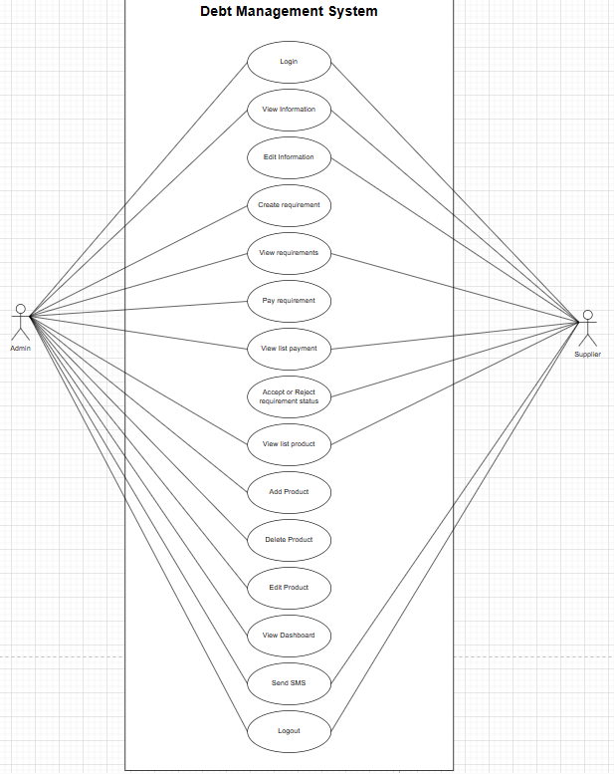

1. **Database Design**

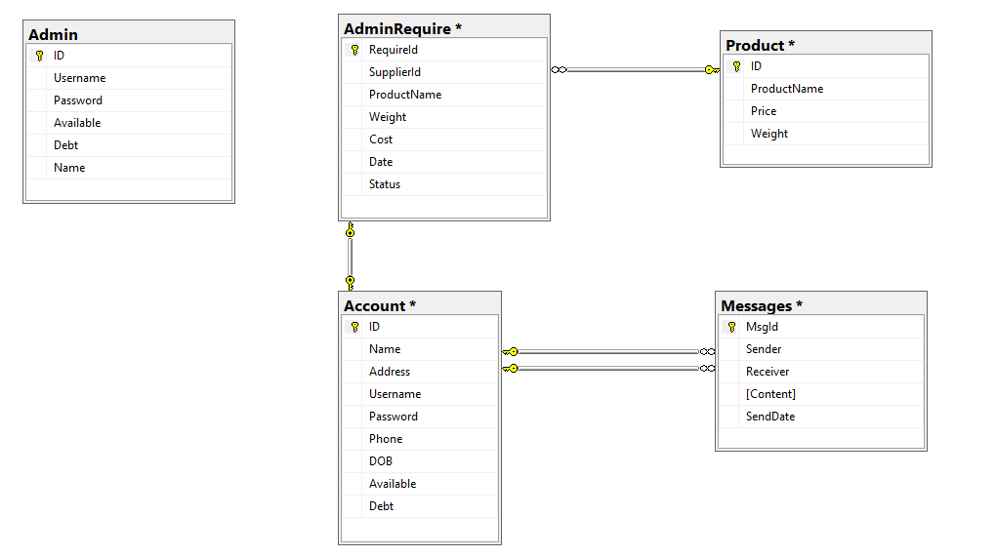

1. **System Architecture**

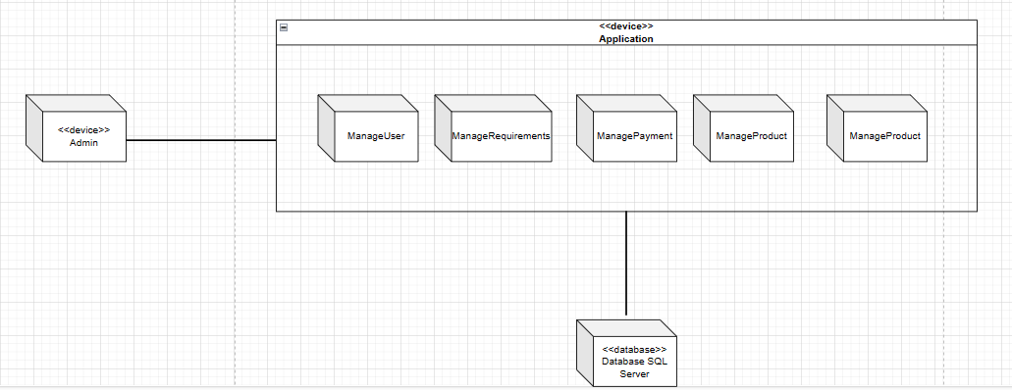

1. **Implementation**
   1. **Installation Instruction:**

Environments and software require:

* Operating system: Windows 10 (or newer)
* SQL Server Management Studio 2019
  1. **Screenshots and explanation:**

1. Login:

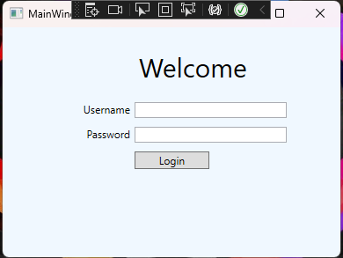

Admin login by admin’s account. Supplier login by given account.

1. Menu window

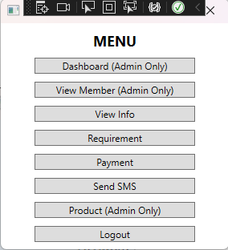

Normal account cannot access to button that have (Admin only).

1. View Member (Admin only)

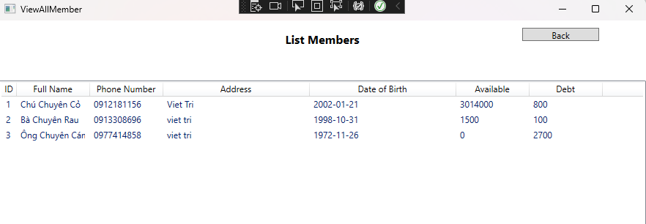Admin can see list of all account information except their username and password.

1. Manage Products (Admin only)

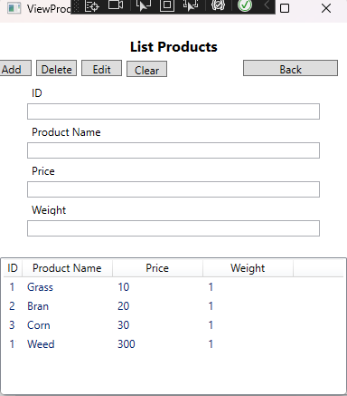

Admin can view all products and manage them. Add, delete, edit product. Clear to empty textboxes.

1. View information

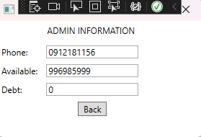

-Admin info

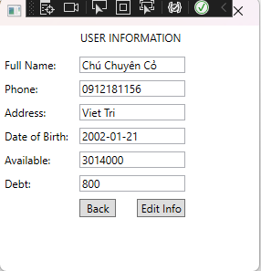

-Supplier info: view all the information of him/her self. Can edit the information by click on “Edit Info” button.

1. Requirement

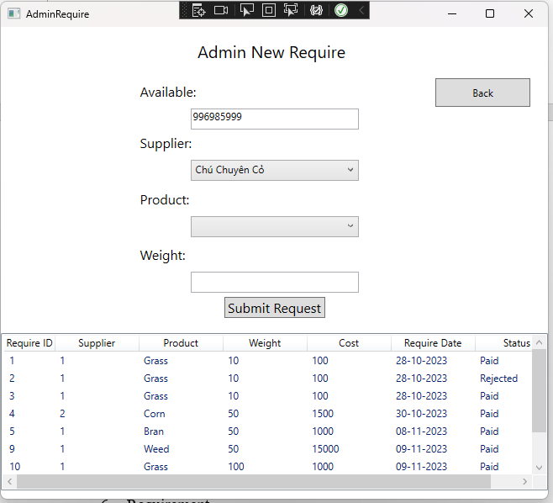

- Admin: Admin input information about new requirement to supplier by choose supplier in combo box, choose product in combo box and input weight (should be a multiple of 10). Status will be “pending” when admin submit a new request and will change depends on which supplier choose “Accepted” or “Rejected”

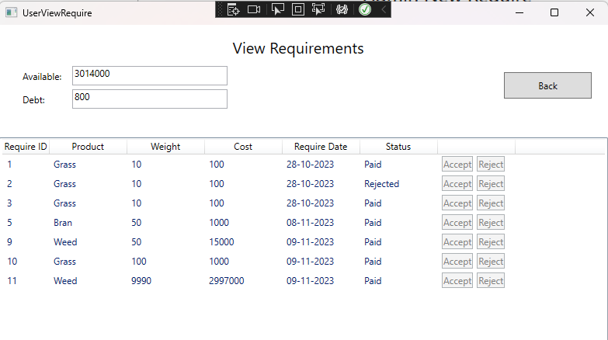

-Supplier: view list of requirements that assigned to him/her and can choose accept or reject that request.

1. Payment

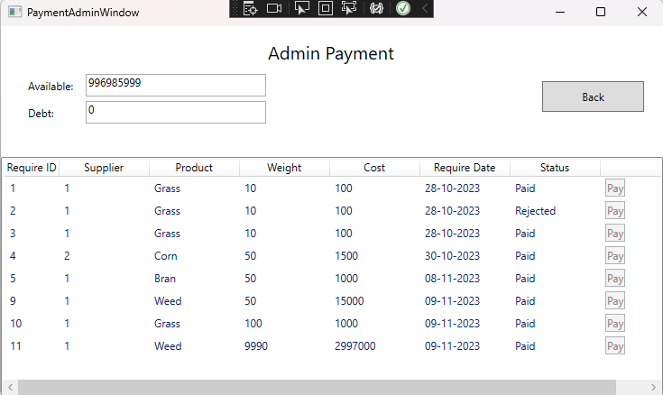

-Admin: view list of all requirements, if supplier accepted then admin can pay for that, cannot otherwise.

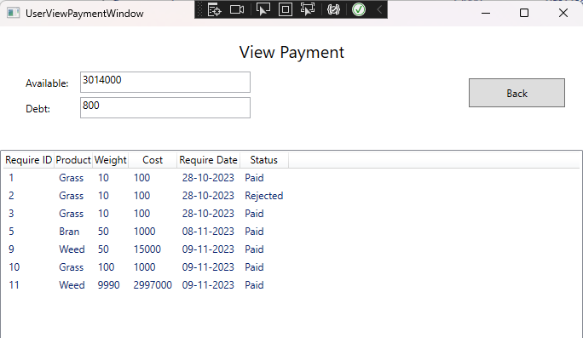

-Supplier: view all the requirements status that are request to him/her self

1. Send SMS

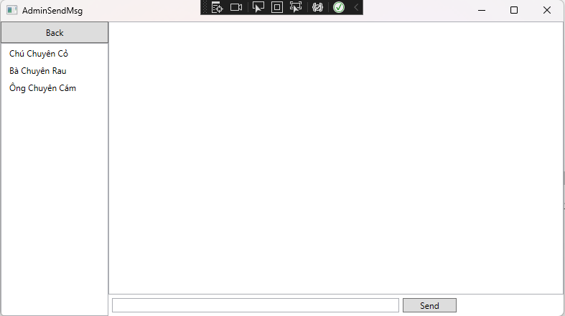

-Admin: on the left is list of suppliers, admin choose one of suppliers to send sms to them

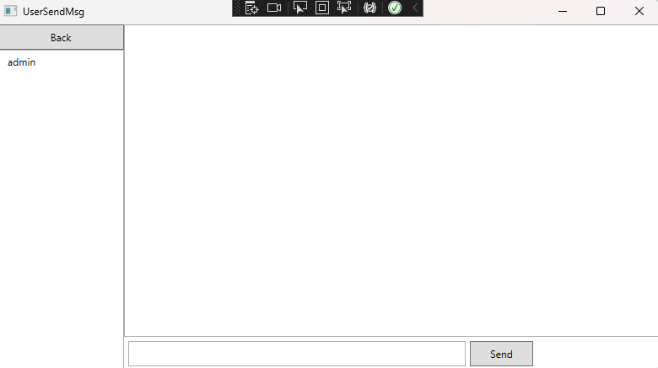

-Supplier: can send sms to admin only.

1. Logout

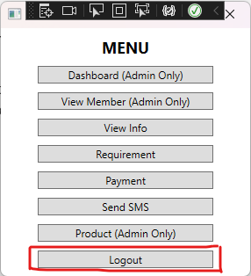

Log out of the system to the login window.